INSTALLATION AND SAFETY INSTRUCTIONS

FOR YOUR SAFETY WARNING
BE SURE THE ELECTRICITY TO THE WIRES YOU ARE WORKING ON IS SHUT OFF; EITHER THE FUSE IS REMOVED OR THE CIRCUIT BREAKER IS SHUT OFF. GENERAL You don’t need special tools to install this fixture. Be sure to follow the steps in the order given. Under no circumstances should a fixture be hung on house electrical wires, nor should a swag type fixture be installed on a ceiling which contains a radiant type heating system. Read instructions carefully. If you are unclear as to how to proceed, consult a qualified electrician. NOTE: Proper wiring is essential for the safe operation of this fixture.
GENERAL
You don’t need special tools to install this fixture. Be sure to follow the steps in the order given. Under no circumstances should a fixture be hung on house electrical wires, nor should a swag type fixture be installed on a ceiling, which contains a radiant type heating system. Read instructions carefully. If you are unclear as to how to proceed, consult a qualified electrician.
NOTE: Proper wiring is essential for the safe operation of this fixture.
FIXTURE ASSEMBLY
Carefully removed the fixture from the carton and check that all
parts are included as shown in figure. Be careful not to misplace
any of the screws or parts, which are needed to install this fixture.
INSTALLATION
IMPORTANT: Do not attach fixture directly to outlet box.
STEP 1: Install bulb (Q) to socket (P) on the lamp No. 1 and place wire shade (U) onto center of round tube (O) lamp No. 1 (Do not exceed the maximum capacity recommended on the socket.)
STEP 2: The hanging pipes (L) for this fixture includes 2 sets :1pc X 3", 1pcs X 6", 5pcs X 12”, choose desired installation height. Thread pipe (L) to the nipple (M). Put the fixture wires through each pipe to be used. Thread all the connected pipes to the fixture nipple (N) on the round tube (O).
STEP 3: Thread top end of pipe assembly into swivel (J). Pass fixture wires through the connected pipes, and swivel (J) in canopy (I) and secure swivel (J) to canopy (I) with
plate washer (H), key washer (G), spring washer and wing nut (E).
STEP 4: Attach two mounting screws (C) to mounting strap (A) and tighten with hex nuts (B). Secure mounting strap (A) to outlet box by threading outlet box screw (D) through the key hole.
GROUNDING INSTRUCTIONS
STEP 1: NEVER CONNECT GROUND WIRE TO BLACK OR WHITE POWER SUPPLY WIRES.
STEP 2: Take note of the color of the wire(s) on your fixture.
Identify which group your fixture wire(s) falls into and connect the wires according to the directions below:
GROUP A: Connect to Black  House Wire | GROUP B: Connect to White  House Wire
BLACK | WHITE
*PARALLEL WIRE (round &  smooth) | *PARALLEL WIRE (square &  ridged)
WHITE OR GREY WITH TRACER | WHITE OR GREY WITHOUT TRACER
BROWN GOLD OR BLACK WITHOUT TRACER | BROWN, GOLD OR BLACK WITH TRACER
*NOTE: When parallel wire (SPT-I & SPT-2) is used, the tracer
wire is square shaped or ridged and the less tracer wire is round
in shape or smooth (seen best when viewed from wire end.)
STEP 3: Take your fixture wire(s) from group A and place
evenly against the black wire from the outlet box. Do NOT twist wires together before using wire connectors.
STEP 4: Fit a wire connector (not supplied) over the wires and
STEP 5: Connect the fixture wire from group B to the white wire from the outlet box in the same manner. Make sure no bare wires can be seen outside wire connectors.
screw the connector clockwise until you feel a firmness.
If you can pull the connector off, carefully re-do steps 3
and 4, as above, and check again for a firm connection
FINAL ASSEMBLY
STEP 1: After the wires connected, raise canopy (I) so the two mounting screws (C) protrude through the holes on canopy (I) then tighten with finials (K).
STEP 2: Install bulbs to remain sockets, slide wire shade (T) onto lamp No. 2, with the “U” shade steel wire on the top of shade face inward, place wire shade (S) onto lamp No. 3 with the extended steel wire on the top of shade face inward and the, place wire shade (R) onto lamp No. 4
with the extended steel wire on the top of shade face inward, the wire shade (R) should be sit inside the pin (X) on the round tube (O)
CLEANING
To clean, wipe fixture with a soft cloth. Clean glass with a mild soap. Do not use abrasive materials such as scouring pads or powders, steel wool or abrasive paper.
ORDERING PARTS
Keep this sheet for future reference, and in case you need to order replacement parts. All parts for this fixture can be ordered from place of purchase. Be sure to use exact wording from illustration when ordering parts.
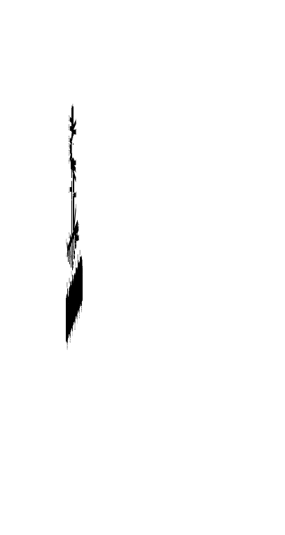

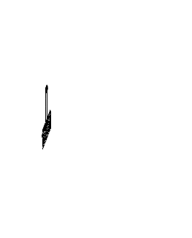

Completed Drawing

Line art shown may not exactly match the fixture enclosed. However, the installations do apply to this fixture.
ITEM NO: 801-7L

